**BANK LOAN REPORT QUERY DOCUMENT**

1. **BANK LOAN REPORT | SUMMARY**

**KPI’s:**

**Total Loan Applications**

SELECT COUNT(id) AS Total_Applications FROM financial_loans

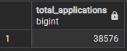

**MTD Loan Applications**

SELECT COUNT(id) AS Total_Applications FROM financial_loans

WHERE EXTRACT(MONTH FROM issue_date) = 12

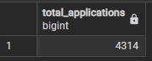

**PMTD Loan Applications**

SELECT COUNT(id) AS Total_Applications FROM financial_loans

WHERE EXTRACT(MONTH FROM issue_date) = 11

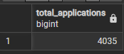

**Total Funded Amount**

SELECT SUM(loan_amount) AS Total_Funded_Amount FROM financial_loans

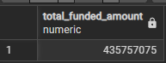

**MTD Total Funded Amount**

SELECT SUM(loan_amount) AS Total_Funded_Amount FROM financial_loans

WHERE EXTRACT(MONTH FROM issue_date) = 12

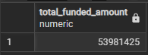

**PMTD Total Funded Amount**

SELECT SUM(loan_amount) AS Total_Funded_Amount FROM financial_loans

WHERE EXTRACT(MONTH FROM issue_date) = 11

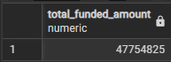

**Total Amount Received**

SELECT SUM(total_payment) AS Total_Amount_Collected FROM financial_loans

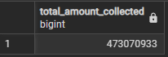

**MTD Total Amount Received**

SELECT SUM(total_payment) AS Total_Amount_Collected FROM financial_loans WHERE EXTRACT(MONTH FROM issue_date) = 12

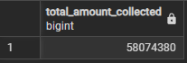

**PMTD Total Amount Received**

SELECT SUM(total_payment) AS Total_Amount_Collected FROM financial_loans WHERE EXTRACT(MONTH FROM issue_date) = 11

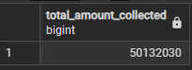

**Average Interest Rate**

SELECT AVG(int_rate)*100 AS Avg_Int_Rate FROM financial_loans

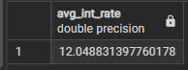

**MTD Average Interest**

SELECT AVG(int_rate)*100 AS Avg_Int_Rate FROM financial_loans WHERE EXTRACT(MONTH FROM issue_date) = 12

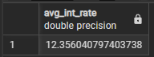

**PMTD Average Interest**

SELECT AVG(int_rate)*100 AS Avg_Int_Rate FROM financial_loans WHERE EXTRACT(MONTH FROM issue_date) = 11

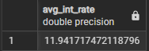

**Avg DTI**

SELECT AVG(dti)*100 AS Avg_DTI FROM financial_loans

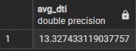

**MTD Avg DTI**

SELECT AVG(dti)*100 AS Avg_DTI FROM financial_loans WHERE EXTRACT(MONTH FROM issue_date) = 12

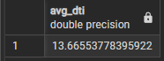

**PMTD Avg DTI**

SELECT AVG(dti)*100 AS Avg_DTI FROM financial_loans WHERE EXTRACT(MONTH FROM issue_date) = 11

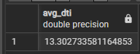

**GOOD LOAN ISSUED**

**Good Loan Percentage**

SELECT (COUNT(CASE WHEN loan_status = 'Fully Paid' or loan_status = 'Current' THEN id END) * 100)/COUNT(id) as Good_Loan_Percentage FROM financial_loans

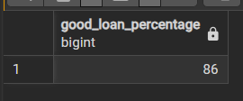

**Good Loan Applications**

SELECT COUNT(id) AS Good_Loan_Applications FROM financial_loans

WHERE loan_status = 'Fully Paid' OR loan_status = 'Current'

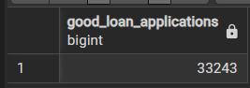

**Good Loan Funded Amount**

SELECT SUM(loan_amount) AS Good_Loan_Funded_amount FROM financial_loans

WHERE loan_status = 'Fully Paid' OR loan_status = 'Current'

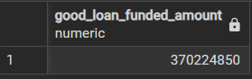

**Good Loan Amount Received**

SELECT SUM(total_payment) AS Good_Loan_amount_received FROM financial_loans

WHERE loan_status = 'Fully Paid' OR loan_status = 'Current'



**BAD LOAN ISSUED**

**Bad Loan Percentage**

SELECT

    (COUNT(CASE WHEN loan_status = 'Charged Off' THEN id END) * 100.0) /

COUNT(id) AS Bad_Loan_Percentage

FROM financial_loans

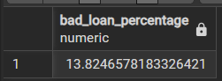

**Bad Loan Applications**

SELECT COUNT(id) AS Bad_Loan_Applications FROM financial_loans

WHERE loan_status = 'Charged Off'

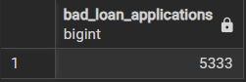

**Bad Loan Funded Amount**

SELECT SUM(loan_amount) AS Bad_Loan_Funded_amount FROM financial_loans

WHERE loan_status = 'Charged Off'

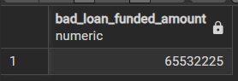

**Bad Loan Amount Received**

SELECT SUM(total_payment) AS Bad_Loan_amount_received FROM financial_loans

WHERE loan_status = 'Charged Off'

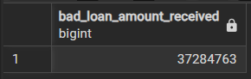

**LOAN STATUS**

SELECT

        loan_status,

        COUNT(id) AS LoanCount,

        SUM(total_payment) AS Total_Amount_Received,

        SUM(loan_amount) AS Total_Funded_Amount,

        AVG(int_rate * 100) AS Interest_Rate,

        AVG(dti * 100) AS DTI

    FROM

        financial_loans

    GROUP BY

        loan_status

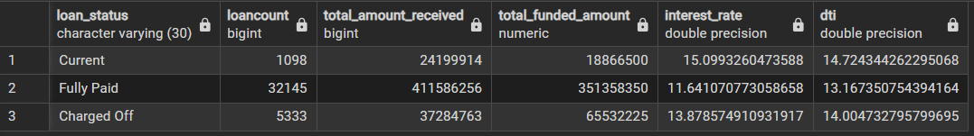

SELECT

loan_status,

SUM(total_payment) AS MTD_Total_Amount_Received,

SUM(loan_amount) AS MTD_Total_Funded_Amount

FROM financial_loans

WHERE EXTRACT(MONTH FROM issue_date) = 12

GROUP BY loan_status

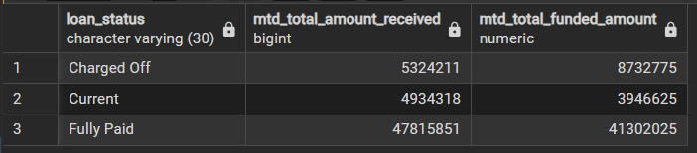

1. **BANK LOAN REPORT | OVERVIEW**

**MONTH**

SELECT

EXTRACT(MONTH FROM issue_date) AS month_number,

TO_CHAR(issue_date, 'Month') AS month_name,

COUNT(id) AS total_loan_applications,

SUM(loan_amount) AS total_funded_amount,

SUM(total_payment) AS total_amount_received

FROM financial_loans

GROUP BY month_number, month_name

ORDER BY month_number;

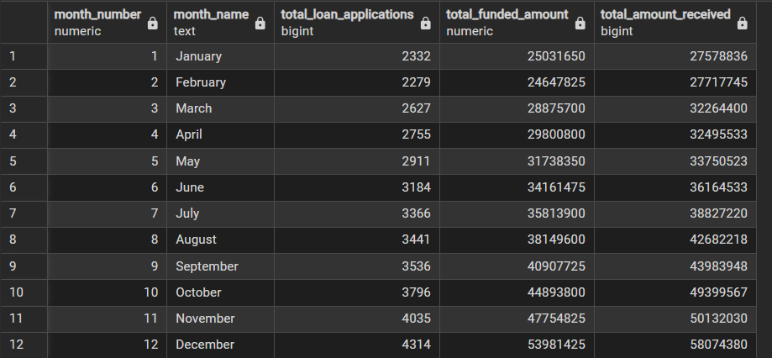

**STATE**

SELECT

address_state AS State,

COUNT(id) AS Total_Loan_Applications,

SUM(loan_amount) AS Total_Funded_Amount,

SUM(total_payment) AS Total_Amount_Received

FROM financial_loans

GROUP BY address_state

ORDER BY address_state

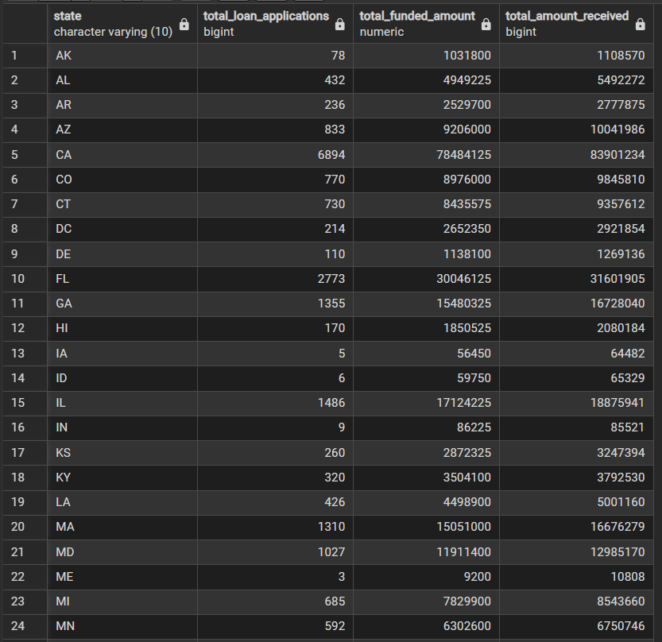

**TERM**

SELECT

term AS Term,

COUNT(id) AS Total_Loan_Applications,

SUM(loan_amount) AS Total_Funded_Amount,

SUM(total_payment) AS Total_Amount_Received

FROM financial_loans

GROUP BY term

ORDER BY term

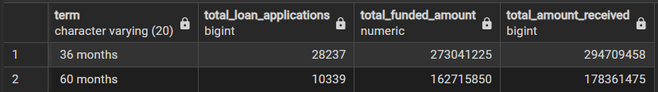

**EMPLOYEE LENGTH**

SELECT

emp_length AS Employee_Length,

COUNT(id) AS Total_Loan_Applications,

SUM(loan_amount) AS Total_Funded_Amount,

SUM(total_payment) AS Total_Amount_Received

FROM financial_loans

GROUP BY emp_length

ORDER BY emp_length

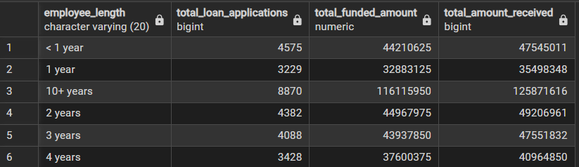

**PURPOSE**

SELECT

purpose AS PURPOSE,

COUNT(id) AS Total_Loan_Applications,

SUM(loan_amount) AS Total_Funded_Amount,

SUM(total_payment) AS Total_Amount_Received

FROM financial_loans

GROUP BY purpose

ORDER BY purpose

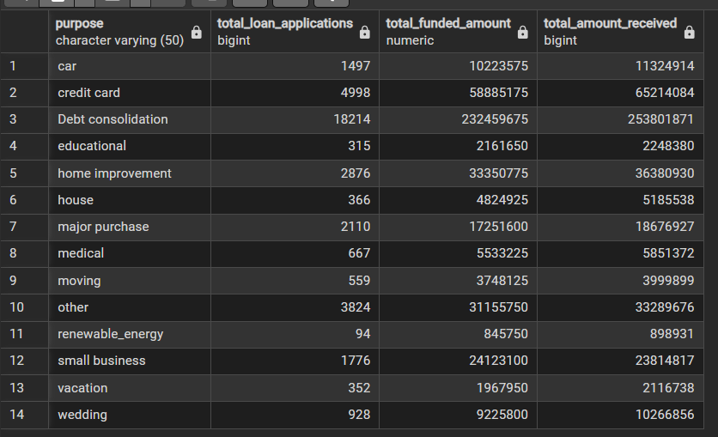

**HOME OWNERSHIP**

SELECT

home_ownership AS Home_Ownership,

COUNT(id) AS Total_Loan_Applications,

SUM(loan_amount) AS Total_Funded_Amount,

SUM(total_payment) AS Total_Amount_Received

FROM financial_loans

GROUP BY home_ownership

ORDER BY home_ownership

